**Influential Software Engineer**

*The Software Engineer I have decided to focus on is Alan Turing. Although Turing is not a software engineer of the traditional sense, he had a massive influence on the age of modern computing. Turing was a brilliant mathematician and cryptologist. He is widely credited with developing the ideas of artificial intelligence and the modern computer. I first encountered Turing in the film ‘The Imitation Game’ – which depicts Turing’s role in cracking the German enigma code during World War II. I found Turing’s creativity and liberal thinking captivating, as he invented the machine on which all modern computers are based. I thought it would be interesting to know more about his life, work, and influence on the modern computing era.*

**Early Life**

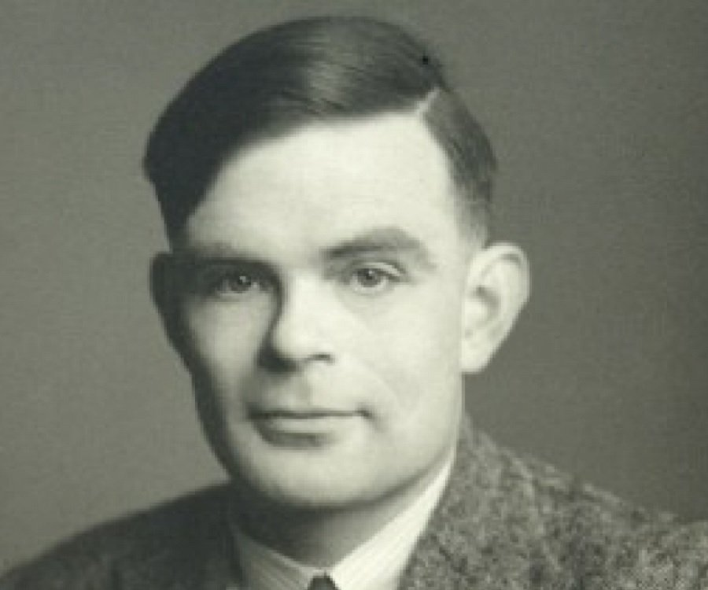Alan Turing was born on June 23rd 1912 to an upper-middle-class family in London, England. Turing’s father worked as an official in the Indian Civil Service until 1926, and as a result his two sons saw very little of their parents growing up. Alan and his older brother John spent their early years being fostered by a retired army Colonel in Hastings. From a young age, Turing expressed an interest in science and mathematics and displayed a high intelligence. However, his intelligence was rarely recognized or respected.

**Sherborne School**

Turing attended the well-respected boarding school Sherborne School from the age of thirteen. A rail strike took place on his very first day of term, but such was his determination to make it to school that he undertook a 97km overnight journey on his bicycle. Sherborne was a typical English public school and emphasis in education was put on the classics. Turing’s natural inclination towards maths and science was not appreciated, and his reports were very poor. He was almost prevented from taking his School Certificate (which is now known as the GCSEs) for fear he would bring shame on the school with his failure. In 1928 Turing entered sixth form in Sherborne and was permitted to specialise in maths and science. He began to excel in his field, taking influence from the work of Albert Einstein, whom he studied in depth. While in sixth form Turing met Christopher Morcom, another incredibly bright student whom Turing formed a close bond with. However, Morcom passed away from an illness in 1930 – an event which greatly impacted Turing and influenced his line of work.

**Cambridge**

Alan Turing won a scholarship to Kings College, Cambridge University. From 1931 he was an undergraduate student there studying mathematics. Unlike Sherborne, Turing found a home in Cambridge, where unconventional and liberal thinking were encouraged and accepted. He graduated with a first class honors degree and in 1935 was elected a fellow of Kings College based on a dissertation in which he proved the Central Limit Theorem.

**Mathematical Logic**

In the early 1930’s Turing’s interests began to grow and develop. He read about mathematical logic in the work of Bertrand Russell and began to study this field. It is at this time that Turing introduced the basic principle of what we know as the modern computer—the idea of controlling a machine's operations using a program of coded instructions stored in the computer's memory. In perhaps his most famous paper *‘On computable numbers, with an application to the Entscheidungsproblem 1936-7’* Turing stated that by following a methodical process, mathematical problems could be solved mechanically. He presented the idea of the Turing Machine – a machine capable of performing any solvable mathematical computation provided it was represented as an algorithm. Turing theorized that more complex tasks did not require a more complex machine. One machine would be capable of solving all degrees of problems and a complex task simply required a greater storage capacity. Although this concept might seem obvious, in 1936 when engineers built specific machines for specific purposes only, this idea was revolutionary. Turing’s paper was unique in that it bridged together logic, the action of the mind and a machine. Today, people all over the world view this paper as the beginning of computer science.

**Princeton**

After graduating from Cambridge Turing spent two years at Princeton University, New Jersey. Here he enrolled as a graduate and furthered his studies in mathematics and cryptology while attaining his Ph.D. Turing analysed the idea of 'intuition' in mathematics, and introduced the idea of oracular computation, which is fundamental to the concept of recursion in computer programming today. Although while in America Turing furthered his studies into mathematic logic, he would never pursue these developments as his logical skills and ideas were demanded for more immediate problems – namely the second world war.

**Bletchley Park**

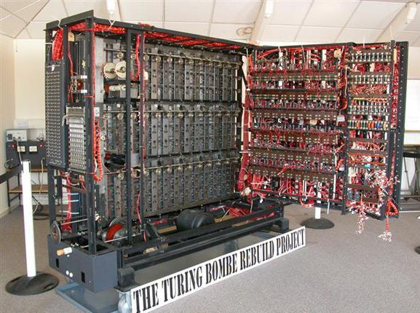Upon returning to Cambridge in summer 1938, Turing secretly worked part-time for the Government Code and Cypher School, the British code-breaking organisation. Britain declared war on the 3rd September 1939, and by the very next day Alan Turing had taken up a full time position at the wartime cryptanalytic headquarters, Bletchley Park. Here Turing made many brilliant advances in the field of cryptology and computing. Turing and another Cambridge mathematician Welchman developed the crucially important electro-mechanical deciphering machine known as the *Bombe*. This machine was built on earlier work by Polish mathematicians, and was used to decode all messages sent using the Enigma machines of the German air force. The Enigma machines of the German navy - *U-Boats* - were much more complex, and considered unbreakable. Turing was happy to take on this challenge often in solidarity, as others believed it an impossible task. Thanks to Turing's statistical approach, together with captured information, by summer of 1941 German navy signals were also being decoded at Bletchley. By the end of 1941, as the Americans entered the war, the Allies had taken the upper hand in the battle of the Atlantic thanks to the messages being decoded at

Bletchley Park. However, disaster struck when the German’s advanced their navy enigma system meaning Bletchley no longer had the ability to decode German messages. Turing made the trip across the Atlantic in 1942, liaising with the American government over the *U-boat* Enigma crisis and the secret encipherment of speech signals between Presidents Roosevelt and Churchill. Although Alan Turing was not directly involved with the successful breaking of this more complex version of enigma, the physical solution was based on ideas and concepts of his. It is believed that the work of those in Bletchley Park shortened the war by 2 years. Turing’s brilliance in deciphering code and developing computers to assist him in breaking them, may have saved more lives than anyone else during the war. Turing’s intelligence was so far ahead of his times that two papers he wrote about mathematical approaches to code-breaking at this time were so valuable they were not released by the British government until 2012. He received an Order of the British Empire (OBE) for his part in winning the war, although he was not publicly recognised until many years later. As the war came to an end, Turing had become an all-purpose consultant to the Bletchley Park operations. He focused on learning electronics while at Bletchley and began to plan the construction of an electronic Turing Machine – or the world’s first digital computer.

**The Automatic Computing Engine**

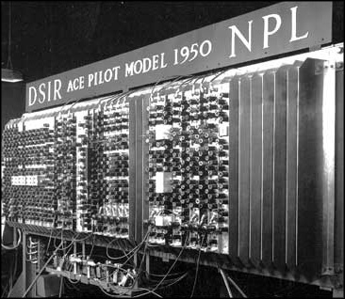In 1945 after the British reigned victorious in the war, Turing was recruited to work for the National Physics Laboratory in London. His task was simple – to design a computer that upstaged the plans of a rival American scientist. At last he had an opportunity to build the concrete form of his Turing Machine. However, Turing’s idea for this machine had developed from his original 1936 concept. He was overwhelmed by the potential held by the computer he had conceived. Turing produced a report proposing the Automatic Computing Engine (which was abbreviated to the ACE). The ACE was the first relatively complete specification of a general-purpose digital computer. Ahead of his time, Turing saw that speed and memory were two of the most important aspects of computing. The size of storage he prescribed for the ACE was regarded sceptically by most as impossibly over-ambitious. Had Turing’s ACE been built to design it would have had a closer resemblance to the computers we use today than the machines of his time. Unfortunately, Turing’s colleagues at the NPL believed it was too difficult a feat of engineering and the ACE was not built during his lifetime. For many years Turing’s ACE was used as a blueprint for personal computers, with machines deriving from his original design being built into the 1970s.

**Artificial Intelligence**

Turing was a founding father of the concepts of Artificial Intelligence and modern cognitive science. He believed that the human brain was similar to a digital computing machine, theorising that at birth the brain was an 'unorganised machine' which through 'training' becomes organised 'into a universal Turing machine or something like it'.

He became captivated by the idea machinery should be able to acquire and exhibit the characteristics of a human mind. He often referred to the idea of ‘building a brain’ when designing computers. In 1950 Turing published ‘*Computing machinery and intelligence in Mind*.’ In this paper he proposed an experiment ‘The Turing Test’. The test can be viewed as an 'imitation game', in which a human and a computer would be interrogated under conditions where the person interrogating them would not know which was which, communication being limited to only textual messages. Turing argued that if the interrogator could not distinguish between the man and computer, then one should consider the computer intelligent, because we judge other people's intelligence from external observation in just this way. Today, this test is still applied by people when attempting to answer whether a computer has intelligence. It was in this period of his life that Alan Turing began running competitively. After the war, he became a member of Walton Athletic Club. He would amaze his colleagues, electing to run long distances to meetings and often beating those on public transport. He was a seriously considered prospect for the British team in the 1948 Olympic Games, but was ultimately ruled out due to an injury.

**Final Years**

Turing spent the final years of his illustrious career working in Manchester University, where he was appointed to a specially created Readership in the Theory of Computing in May 1953. In Manchester Turing’s work included software development and the application of mathematical theory to biology. His work continued to gain recognition and respect, and in 1951 he was elected as a Fellow of the Royal Society of London. Turing’s fortune changed dramatically in March 1952 when he was prosecuted for his homosexuality which was then considered a crime in Britain. Turing had always been open about his sexuality, and did not deny charges against him, offering no defence other than that he saw nothing wrong with his actions. He was sentenced to a year of hormone 'therapy' and striped of his security clearance which prevented him from continuing his work on cryptography with the Government Code and Cypher School. Turing died of cyanide poison on June 7, 1954. A half-eaten apple laced with the poison was found next to his body. Although nothing in his final days suggested he was suicidal, his death was ruled a suicide.

*I found Turing a really intriguing figure to research. His contributions to modern computing, cryptography, artificial intelligence, and computer science on a whole were groundbreaking. Turing was not afraid to think outside the box and introduce ideas and concepts that were years beyond the understanding of his generation. In regards to his personal life, his story is captivating if not tragic. Often misunderstood, I can’t help but admire the integrity and self-belief that Turing displayed throughout his life. The full extent of his brilliance was not appreciated until after his death.*

By Aoife Tiernan

Sources:

1. <http://www.turing.org.uk/publications/dnb.html>
2. <http://www.alanturing.net/turing_archive/pages/Reference%20Articles/Bio%20of%20Alan%20Turing.html>
3. <http://www-groups.dcs.st-and.ac.uk/history/Biographies/Turing.html>